Intel Kabylake CPU Processors with Windows 7 64-bits OS Test Analysis

SBC Board : PCIE-Q170-i2-R10 (Intel Skylake)

Backplane : SPXE-14S-R10

CPU Processor : Intel i7-7700K (Intel Kabylake CPU Processor)

Windows OS : Windows 7 64-bits OS

Memory Module : Transcend 8GB DDR4 Memory Module

Power Supply : ACE-832AP-RS

Display Device : Full HD VGA Monitor

HDD Device : Seagate 500GB SATA

Drivers :

|  |  |
| --- | --- |
| Chipset Drivers | 10.1.1.42 |
| Graphics Drivers | 21.20.16.4678 |
| Audio Drivers | 6.0.1.8036 |
| ME Drivers | 11.0.0.1176 |
| LAN Drivers | 12.12.226.0 |
| RAID Drivers | N/A |
| AHCI Drivers | N/A |
| USB3.0 Drivers | 10.0.15063.0 |

Things to consider during the test:

1. Customer needs to add the USB Driver into their Windows 7 64-bits OS installer. This is because USB Driver for Intel Skylake/Kabylake is not included on the Windows 7 installer.
2. Customer can only use Intel HD Graphics 630 Driver 21.20.16.4678 with the Windows 7 64-bits OS.
3. With igdlh64.inf file was modified, IEI cannot guarantee that all functions from the Graphics Controller will work efficiently. There may be some profound issue might occur and IEI is not liable for this issues.
4. Like for Intel i7-7700, it has an Intel HD Graphics 630 and the Hardware ID is 5912. Where in for Intel i7-7200, it has an Intel HD Graphics 620 and the Hardware ID is 5916.

Standard VGA Graphics Adapter Driver installed:

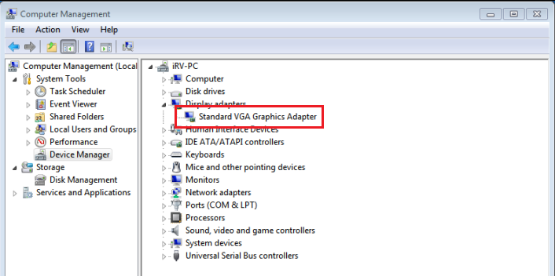

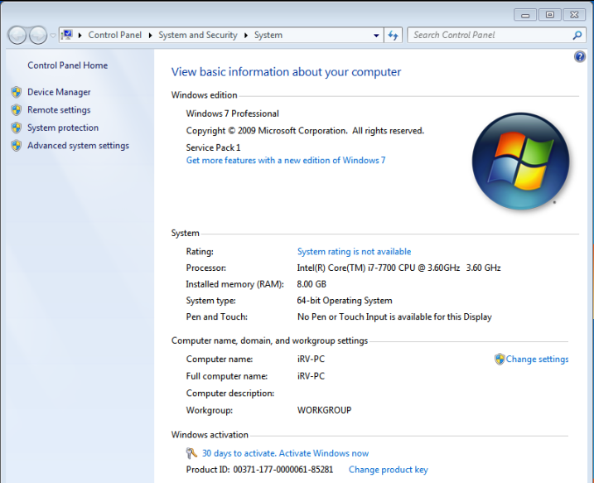

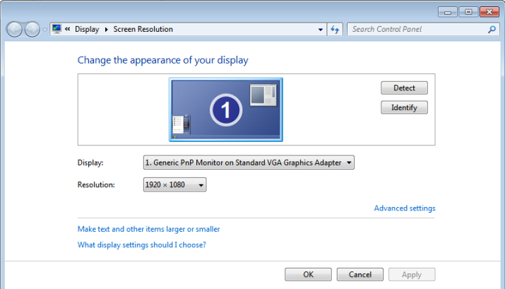

Directly installing the win64_154519.4678 driver below error message will appear:

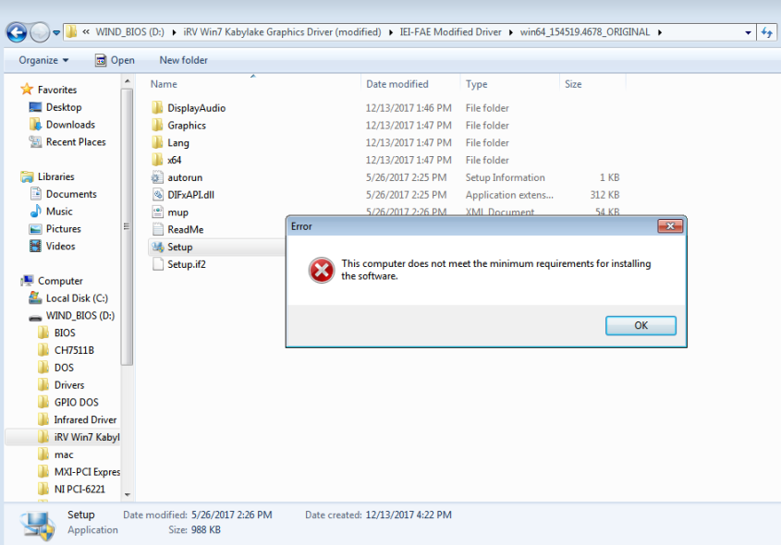

Modify the igdlh64.inf file from the win64_154519.4678 driver in reference with the Intel HD Graphics 630 Hardware ID information [5912]:

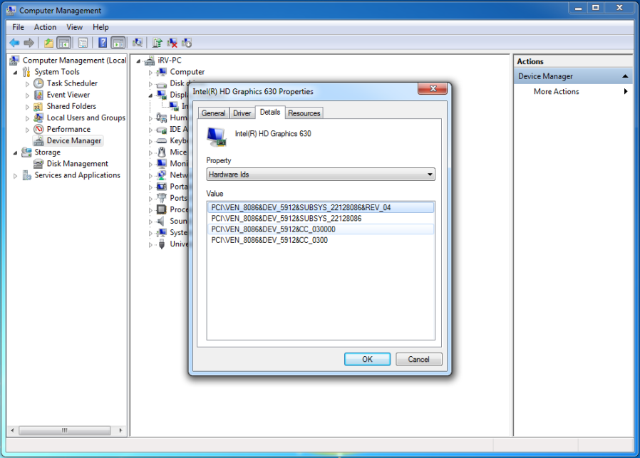

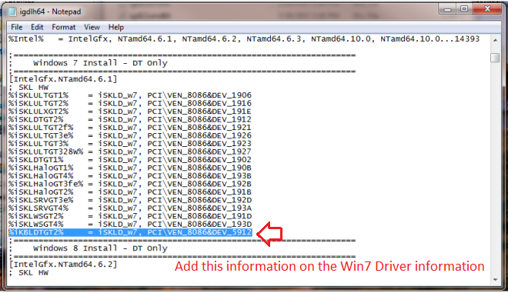

Installing the modified win64_154519.4678 driver:

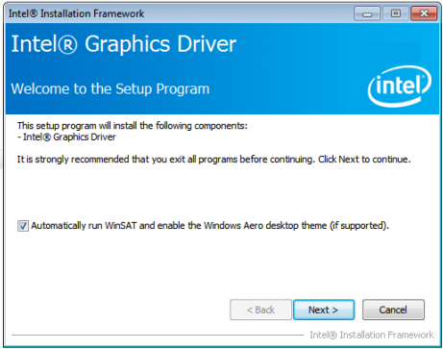

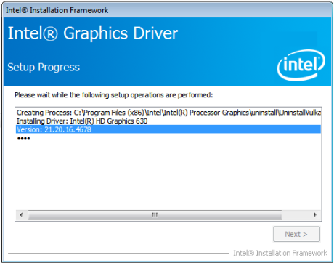

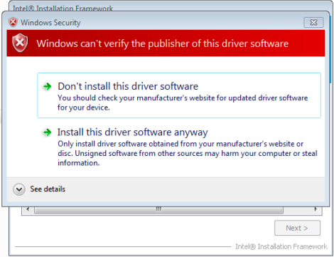

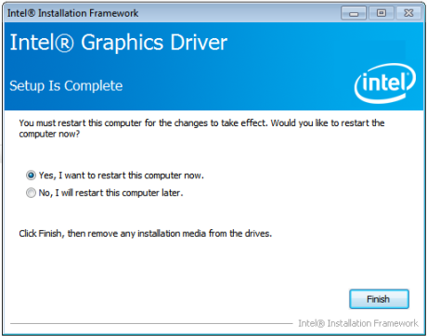

Device Manager after installing the modified igdlh64.inf file:

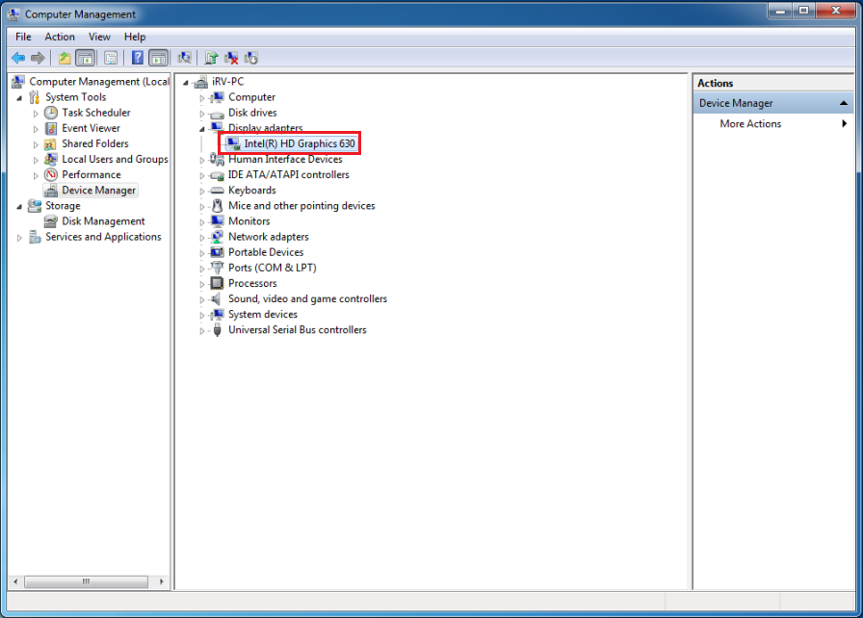

Intel HD Graphics 630 Properties:

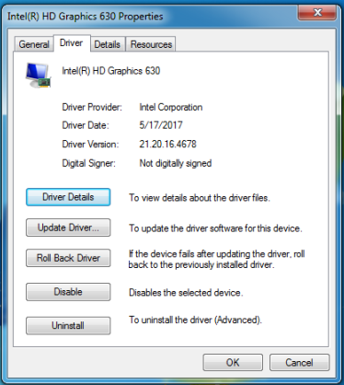

**Important Notice (Not an Official Intel Driver)!!!**

As the igdlh64.inf file has been modified, IEI does not guarantee that this Graphics Drivers will fully support the Intel Kabylake CPU Processor used with IEI Skylake Platforms.

The installation has been successful but IEI may be some unknown issues might occur later and IEI is not liable for these issues.